training 1 epoch...

512.2239060401917 seconds used......

1 training finished! average train loss: 0.28464737694781844

evaluating...

Confusion matrix, without normalization

[[ 20 96 18]

[ 11 1895 31]

[ 1 38 368]]

Normalized confusion matrix

[[0.14925373 0.71641791 0.13432836]

[0.00567888 0.97831699 0.01600413]

[0.002457 0.09336609 0.9041769 ]]

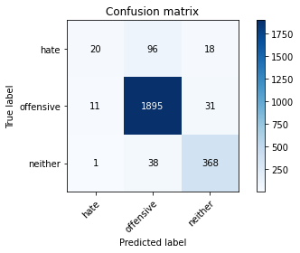

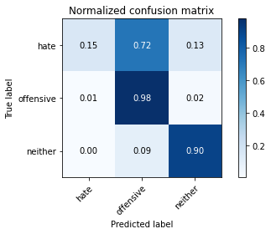

precision recall f1-score support

hate 0.62 0.15 0.24 134

offensive 0.93 0.98 0.96 1937

neither 0.88 0.90 0.89 407

accuracy 0.92 2478

macro avg 0.81 0.68 0.70 2478

weighted avg 0.91 0.92 0.91 2478

average eval_loss: 0.22929962143121707, accuracy: 0.9213075060532687

training 2 epoch...

511.8008689880371 seconds used......

2 training finished! average train loss: 0.20556654289342283

evaluating...

Confusion matrix, without normalization

[[ 30 84 20]

[ 15 1890 32]

[ 1 35 371]]

Normalized confusion matrix

[[0.2238806 0.62686567 0.14925373]

[0.00774393 0.97573567 0.01652039]

[0.002457 0.08599509 0.91154791]]

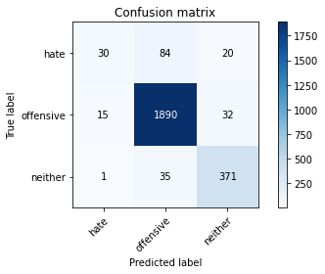

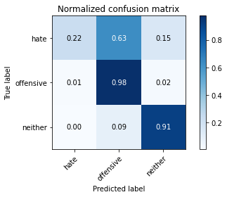

precision recall f1-score support

hate 0.65 0.22 0.33 134

offensive 0.94 0.98 0.96 1937

neither 0.88 0.91 0.89 407

accuracy 0.92 2478

macro avg 0.82 0.70 0.73 2478

weighted avg 0.91 0.92 0.91 2478

average eval_loss: 0.22866974096564996, accuracy: 0.9245359160613398

training 3 epoch...

511.9719007015228 seconds used......

3 training finished! average train loss: 0.14642263991951157

evaluating...

Confusion matrix, without normalization

[[ 47 72 15]

[ 40 1859 38]

[ 4 25 378]]

Normalized confusion matrix

[[0.35074627 0.53731343 0.1119403 ]

[0.02065049 0.95973154 0.01961797]

[0.00982801 0.06142506 0.92874693]]

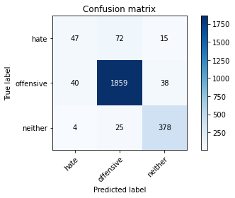

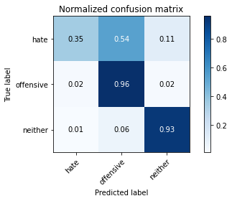

precision recall f1-score support

hate 0.52 0.35 0.42 134

offensive 0.95 0.96 0.96 1937

neither 0.88 0.93 0.90 407

accuracy 0.92 2478

macro avg 0.78 0.75 0.76 2478

weighted avg 0.91 0.92 0.92 2478

average eval_loss: 0.2566814390011132, accuracy: 0.9217110573042776

training 4 epoch...

511.64189052581787 seconds used......

4 training finished! average train loss: 0.09261542350800629

evaluating...

Confusion matrix, without normalization

[[ 46 73 15]

[ 28 1882 27]

[ 6 35 366]]

Normalized confusion matrix

[[0.34328358 0.54477612 0.1119403 ]

[0.01445534 0.97160558 0.01393908]

[0.01474201 0.08599509 0.8992629 ]]

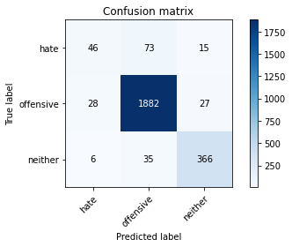

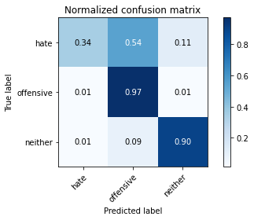

precision recall f1-score support

hate 0.57 0.34 0.43 134

offensive 0.95 0.97 0.96 1937

neither 0.90 0.90 0.90 407

accuracy 0.93 2478

macro avg 0.81 0.74 0.76 2478

weighted avg 0.92 0.93 0.92 2478

average eval_loss: 0.31529677211261925, accuracy: 0.9257465698143664

training 5 epoch...

511.4754238128662 seconds used......

5 training finished! average train loss: 0.05281535981007877

evaluating...

Confusion matrix, without normalization

[[ 41 78 15]

[ 21 1881 35]

[ 4 45 358]]

Normalized confusion matrix

[[0.30597015 0.58208955 0.1119403 ]

[0.01084151 0.97108931 0.01806918]

[0.00982801 0.11056511 0.87960688]]

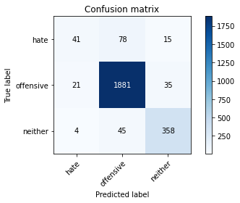

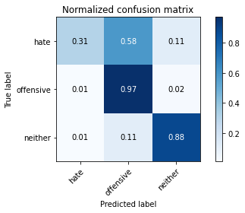

precision recall f1-score support

hate 0.62 0.31 0.41 134

offensive 0.94 0.97 0.95 1937

neither 0.88 0.88 0.88 407

accuracy 0.92 2478

macro avg 0.81 0.72 0.75 2478

weighted avg 0.91 0.92 0.91 2478

average eval_loss: 0.35623225587656754, accuracy: 0.9200968523002422

model of 3 epoch

Confusion matrix, without normalization

[[ 44 72 8]

[ 59 1841 42]

[ 13 26 374]]

Normalized confusion matrix

[[0.35483871 0.58064516 0.06451613]

[0.03038105 0.94799176 0.02162719]

[0.031477 0.062954 0.90556901]]

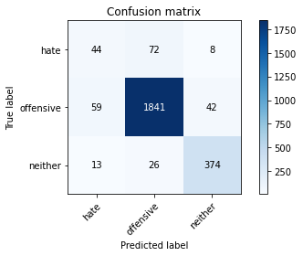

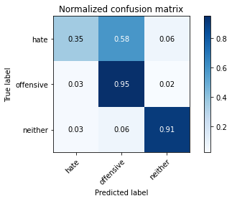

precision recall f1-score support

hate 0.38 0.35 0.37 124

offensive 0.95 0.95 0.95 1942

neither 0.88 0.91 0.89 413

accuracy 0.91 2479

macro avg 0.74 0.74 0.74 2479

weighted avg 0.91 0.91 0.91 2479

average eval_loss: 0.26866360989609556, accuracy: 0.9112545381202097